Chang’an University 2025－2026 The 2nd semester （ A ）
Course | Hydraulic and Pneumatic Transmission |  |  | Date |  | / / |  | 18 questions
Name |  | School |  |  | Class |  | ID
I Fill in the blanks. (20 points, 1 point for each blank)
- The working pressure in a hydraulic system depends on ( ); the speed of the actuator depends on ( ).
- Liquids that are assumed ( ) and ( ) are called ideal fluids.
- The viscosity of liquid ( ) with increasing temperature; the viscosity of gas ( ) with increasing temperature.
- There are two flow regimes in pipelines: ( ) (dominated by viscous force) and ( ) (dominated by inertial force).
- Pressure loss includes ( ) along pipes and ( ) at local fittings.
- A double-acting vane pump delivers oil ( ) per revolution; a single-acting vane pump delivers oil ( ) per revolution.
- Hydraulic motors convert ( ) energy into ( ) energy.
- The main pressure control valves are relief valve, ( ), ( ), and pressure switch.
- A speed control valve consists of a ( ) and a ( ) in series.
- Sequence action circuits allow several actuator motions to obey the setting scheduled actions in turn. There are two kinds of control methods: ( ) control and ( ) control.
II Single Choice (10 points, 2 points for each)
- The continuity equation is based on ________.
A. energy conservation B. mass conservation C. momentum conservation D. force balance
- To reduce hydraulic shock, we can ________.
A. increase flow rate B. shorten closing time C. lengthen closing time D. increase pipe length
- A variable hydraulic motor can change its ________.
A. pressure B. displacement C. viscosity D. density
- The ________ maintains a constant outlet pressure regardless of inlet pressure.
A. relief valve B. check valve C. pressure reducing valve D. sequence valve
- Which hydraulic circuit is used to maintain a constant pressure in the system ________.
A. Speed control circuit B. Pressure holding C. Synchronization circuit D. Direction control circuit

第 1 页(共 4 页)
III Short answer question items. (30 points, 6 points for each)
- List five components of a hydraulic drive system.

- What are the advantages of hydraulic transmission?

- Explain the trapped-oil phenomenon in gear pumps and give one solution.

- State the working principle of a pressure-limiting variable vane pump.

- Compare relief valve and pressure reducing valve.

IV Diagramming question. (10 points)
Please write the name of basic hydraulic circuits and hydraulic components.
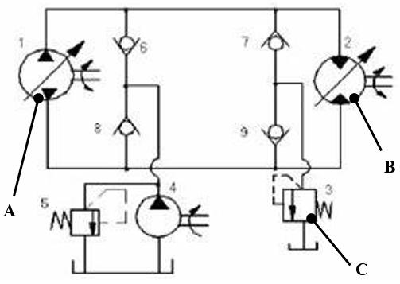 | 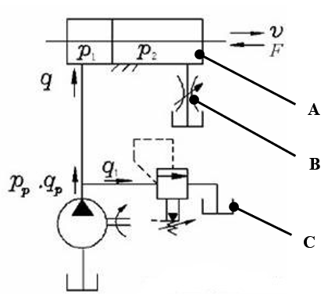
(1) (2)
Hydraulic basic circuit |  |  | Hydraulic basic circuit
Component A |  |  | Component A
Component B |  |  | Component B
Component C |  |  | Component C

第 2 页(共 4 页)

Ⅴ Calculations. (30 points, 10 points for each)
- This is shown in the figure below, known water depth H =10m, section A₁=0.02m², and section A₂= 0.04m², try to find the outflow flow rate of the hole and the surface pressure at point 2 (α=1, regardless of loss).
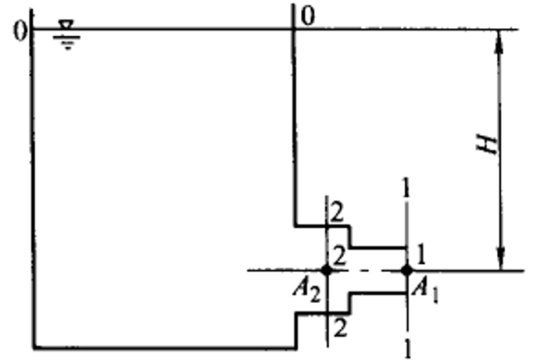

- The inlet pressure of a hydraulic motor is 10MPa, the displacement is 200mL/r, the total efficiency is 0.75, and the mechanical efficiency is 0.9.
1) The theoretical torque that the motor can output.
2) If the speed of the motor is 500r/min, what is the flow rate input to the hydraulic motor?
3) If the external load is 200 N∙m (n= 500r/min), what is the output power and input power of the motor? (10 points)

第 3 页(共 4 页)
- Hydraulic circuit as shown in figure, the no rod cavity area of hydraulic cylinder A=50cm2 , load F=10000N. The set pressure of each valve is shown in the figure, this system is assumed lossless. Calculate the pressure at point A and B when the piston is moving and after the piston moves to the end.
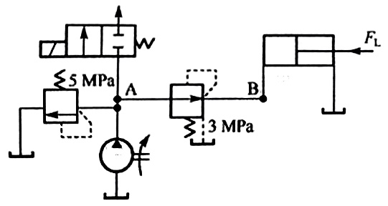

第 4 页(共 4 页)

